

**GOSH: App for child growth charts in R**

**Team 14**

**Rajan Hirani Saleh Khalil Sander Da Mata Miranda**

**COMP103P Applied Software Development**

**April 23, 2018**

*This report is submitted as part requirement for the undergraduate degree at UCL. It is substantially the result of my own work except where explicitly indicated in the text. The report may be freely copied and distributed provided the source is explicitly acknowledged.*

Department of Computer Science

University College London

# Abstract

When children are born, a lot of information is gathered about them as they develop such as weight, height etc. This data is usually visualized in a graph format and generally on paper. With over 130,000 births last year in London alone, a lot of data has to be collected and resources such as paper used to produce the growth charts for this data. This is where our problem lied. Our task was to produce an application for Great Ormond Street Hospital that can produce these growth charts and display useful information to the user about the growth of the child for example, what centile their weight/height lies in etc. Our client also wanted us to make this application available on as many platforms as possible especially mobile devices.

The solution we created was a web app coded in the statistical language R. We used R as it easily allowed us to read and manipulate data from the .csv files in which the information was stored. We used two main libraries from R for our app. Firstly, we used R-Shiny to make our app accessible from the web, allowing our application to be used on all platforms with web functionality. As well as giving us web functionality, R-Shiny provided the resources for us to create a UI for our application. The other library we used was ‘plotly’. This library allowed us to display the growth charts in a visually stimulating format and contained a lot of built in functionality that provides a more robust experience for the user allowing them to zoom in/out, compare data at different points etc. We produced two growth charts for each type of growth and gender. One graph was a measurement/age graph with the child’s data as well as the lines for some centiles so the user can see how child’s growth compares to the rest of the population. The other graph is a z-score/age graph which allows the user to see more explicitly how the child’s growth moves in centiles providing more information to the user.

Given the time restraints and lack of experience with the R programming language, the progress we’ve made with the project is quite remarkable as we met all the essential and most of the optional requirements the client set for us. With this in mind, we can state with confidence that we have produced a complete product. However, the app isn’t ready to be used in hospitals just yet, with more time we could add more functionality and provide a data store such that hospitals can upload their data.

Contents

Abstract 2

1 Introduction 5

2 Requirements 6

2.1 Personas 6

2.2 MoSCoW Requirements 6

3 Research 7

4 Design and Implementation 8

5 Testing 9

5.1 Compatibility Testing 9

5.2 Responsive Design Testing 11

5.3 User Acceptance Testing 14

6 Conclusion and future work 18

6.1 Summary of Achievements 18

6.2 Critical Evaluation of the project 20

6.3 Future Work 21

References 22

Appendix 23

**A** User Manual 23

**B** Deployment Manual 23

**C** Code Citation 23

# 1 Introduction

# 2 Requirements

## 2.1 Personas

Typical users who would use this application would be health centres so that they can monitor the growth of their patients when children come in for their routine check-up. The application could be extended in the future so that any user can use the application so parents can produce their own growth charts for their children.

## 2.2 MoSCoW Requirements

|  |  |  |
| --- | --- | --- |
| ID | Requirements | Priority |
| 1 | Plotting of serial measurements of an individual on a normal growth chart with centile detection | Must |
| 2 | Plot height and weight growth charts | Must |
| 3 | Have web app functionality | Must |
| 4 | Use GOSH’s data to produce growth charts | Must |
| 5 | Show some sort of growth trajectory using the data that is inputted | Should |
| 6 | Integrated with SMART on FHIR so it can be compatible with any health centre that uses SMART on FHIR for their data storage | Should |
| 7 | Have some functionality to output data to files or in a pdf format | Could |
| 8 | Have some functionality for data security | Could |
| 9 | Have some functionality for the application to run in a mobile browser | Could |

**Table 2.1:** MoSCoW Requirements

# 3 Research

# 4 Design and Implementation

# 5 Testing

## 5.1 Compatibility Testing

|  |  |  |
| --- | --- | --- |
| Browser | Version No. | Result |
| Chrome | 65.0.3325.162 | Fully functional |
| Microsoft Edge | 41.16299.248.0 | Fully functional |
| Mozilla Firefox | 59.0 | Fully functional |
| Safari | 11.0.2 | Fully functional |

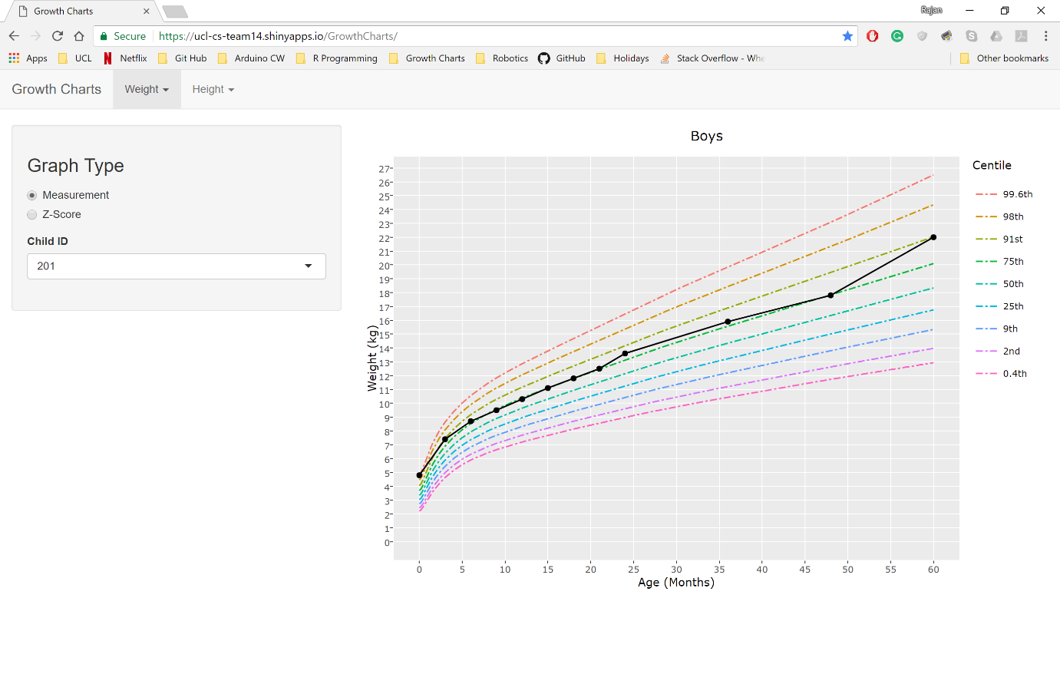

**Figure 5.1:** Google Chrome Screenshot

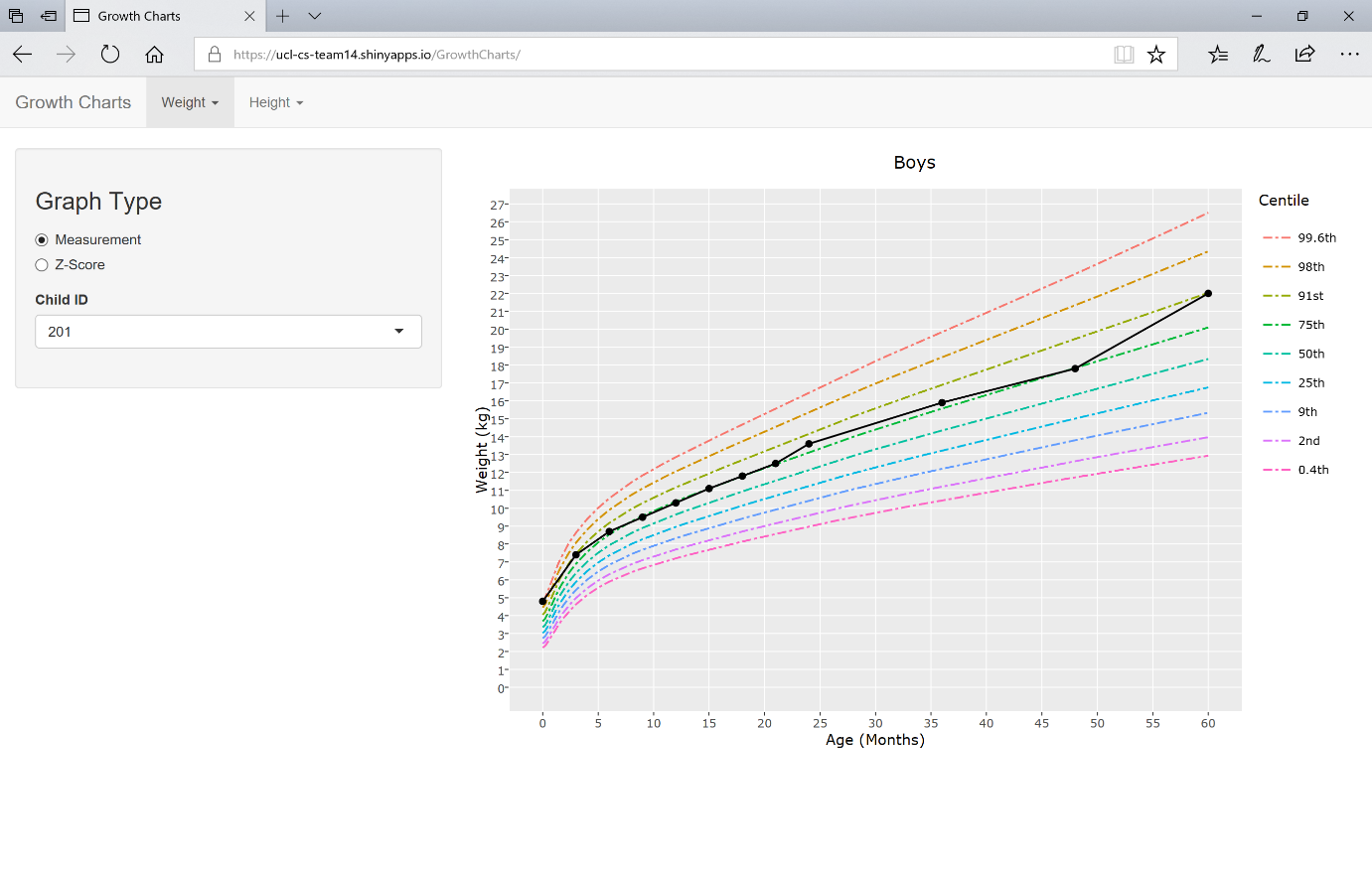

**Figure 5.2:** Microsoft Edge Screenshot

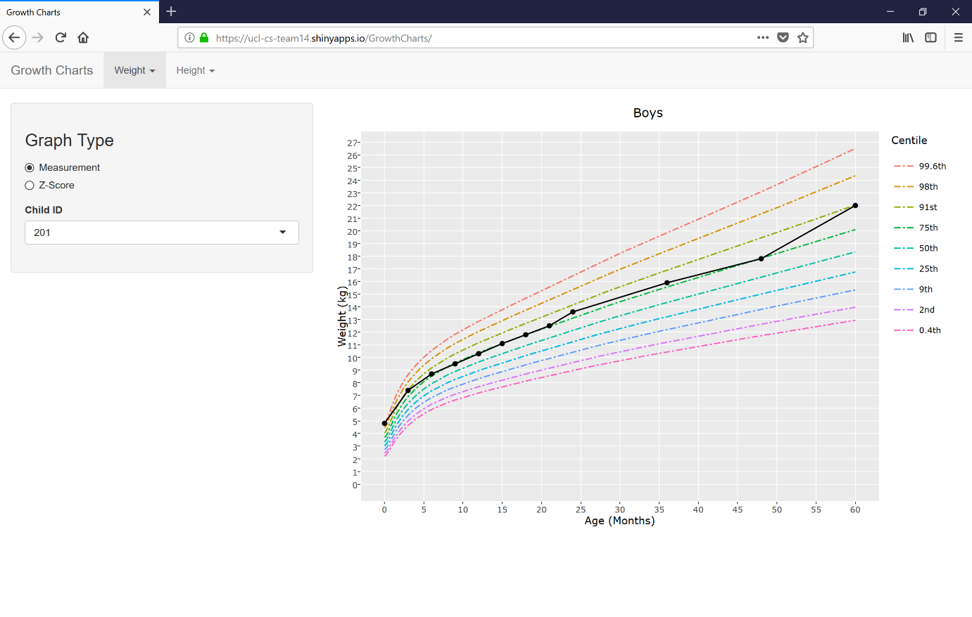

**Figure 5.3:** Mozilla Firefox Screenshot

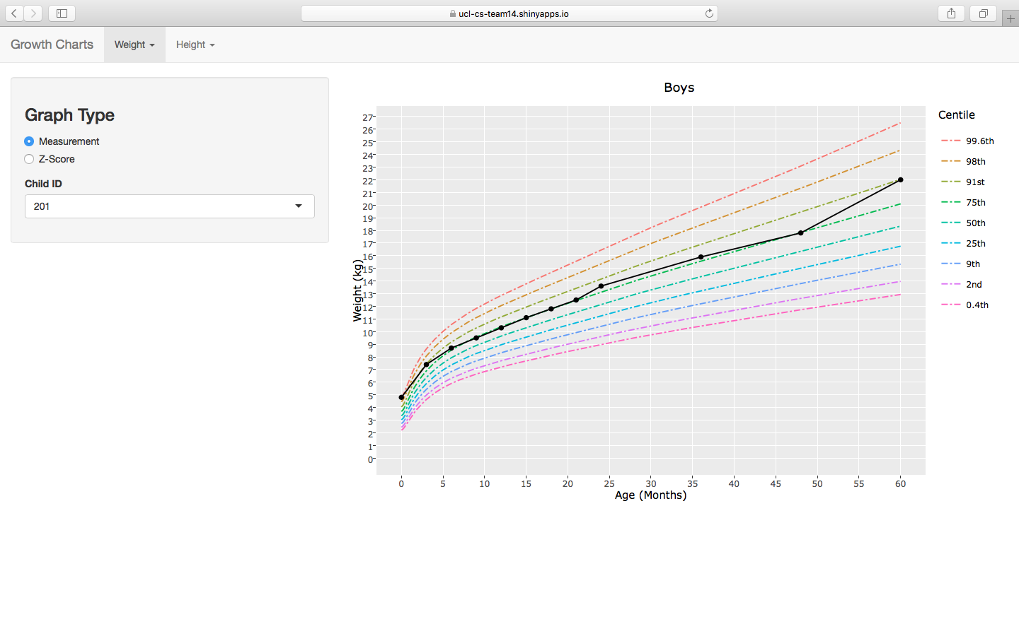

**Figure 5.4:** Safari Screenshot

## 5.2 Responsive Design Testing

|  |  |
| --- | --- |
| Screen | Result |
| Laptop (width 2736px) | Fully functional |
| iPhone 7 | Fully functional |
| iPhone X | Fully functional |
| iPad | Fully functional |



**Figure 5.5:** Laptop Screenshot

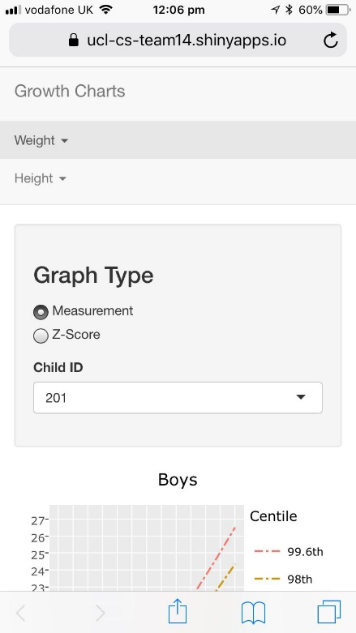

**Figure 5.6:** iPhone 7 Screenshot

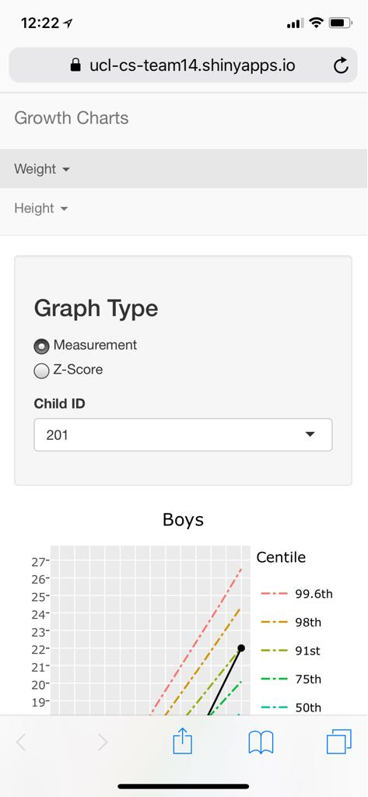

**Figure 5.7:** iPhone X Screenshot

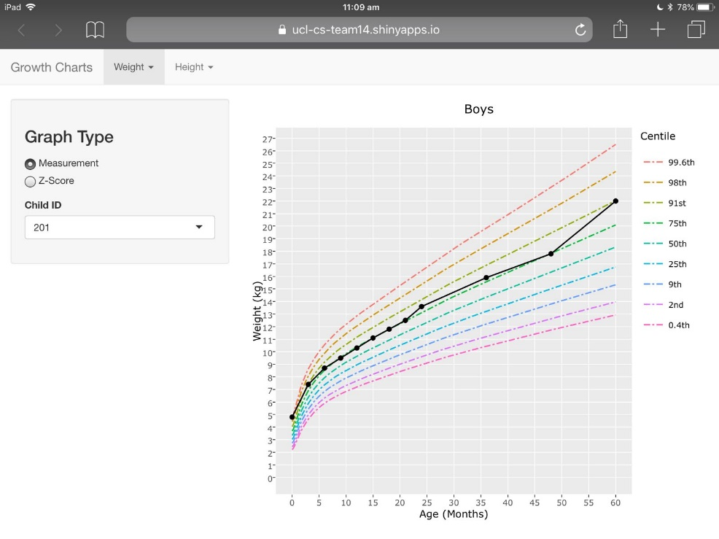

**Figure 5.8:** iPad Screenshot

## 5.3 User Acceptance Testing

A survey was carried out by different users (including our client) asking a variety of questions. These are the results from the survey:

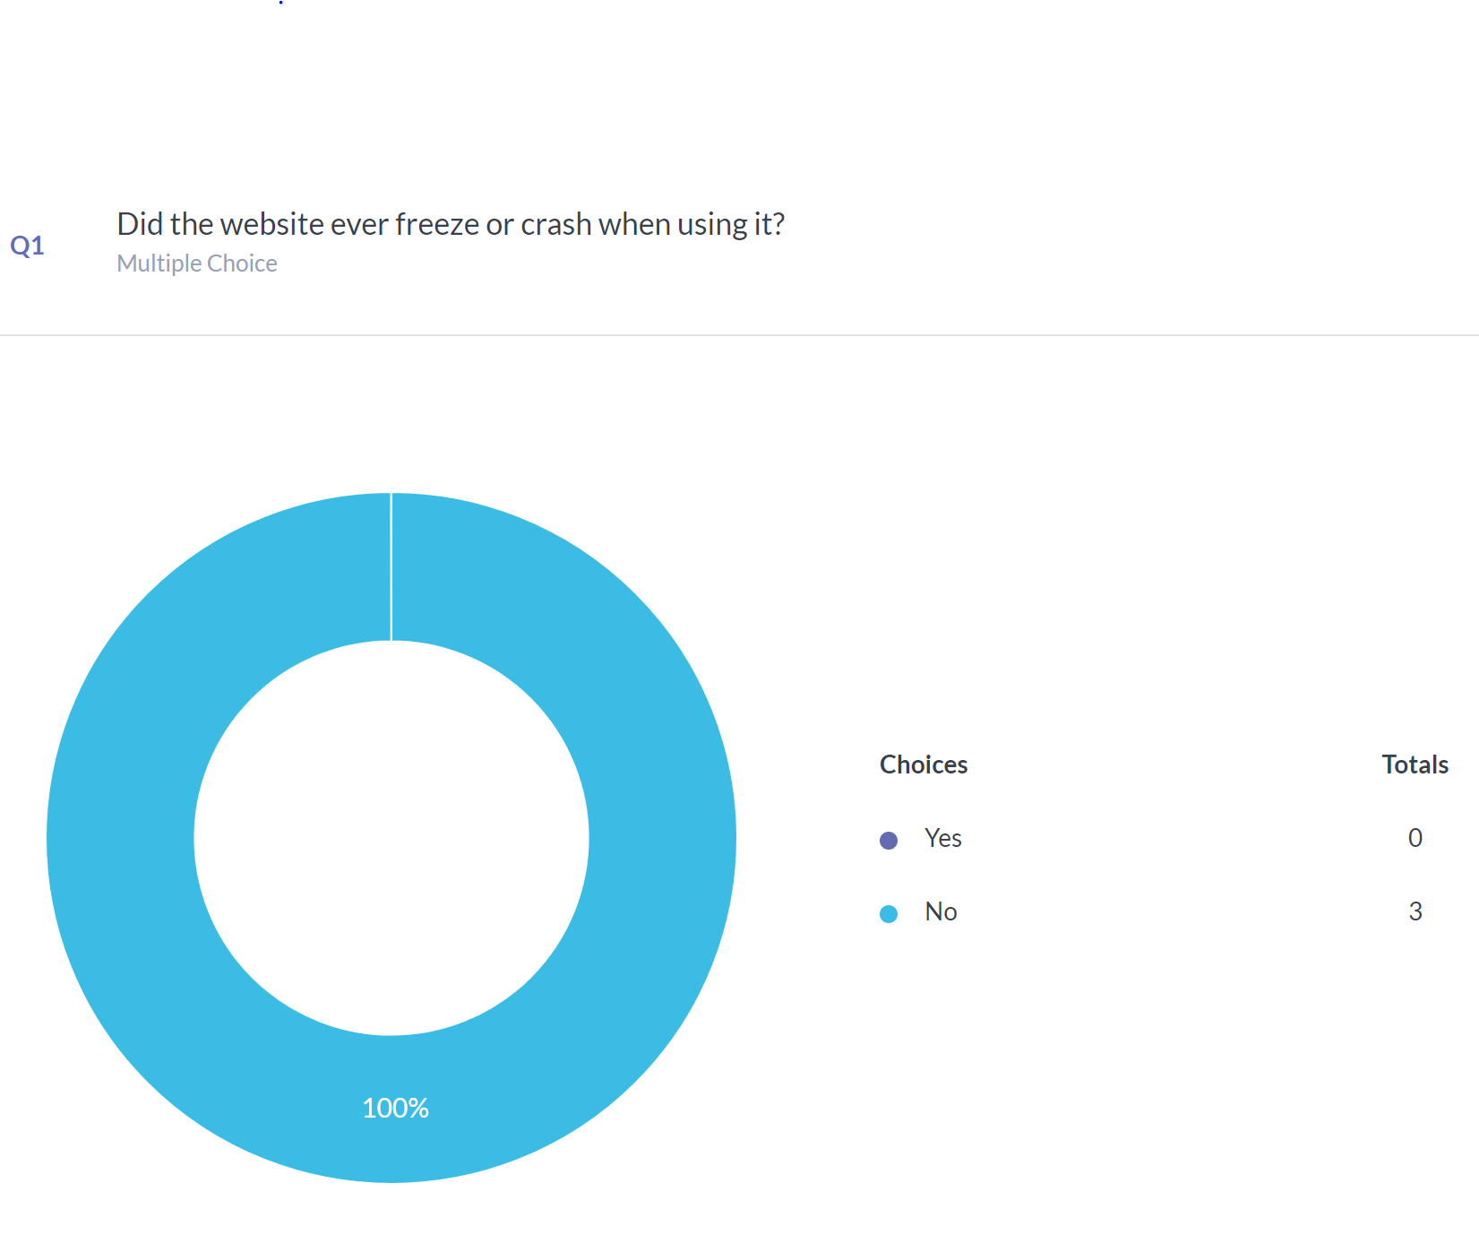

**Figure 5.9:** Question 1 Results

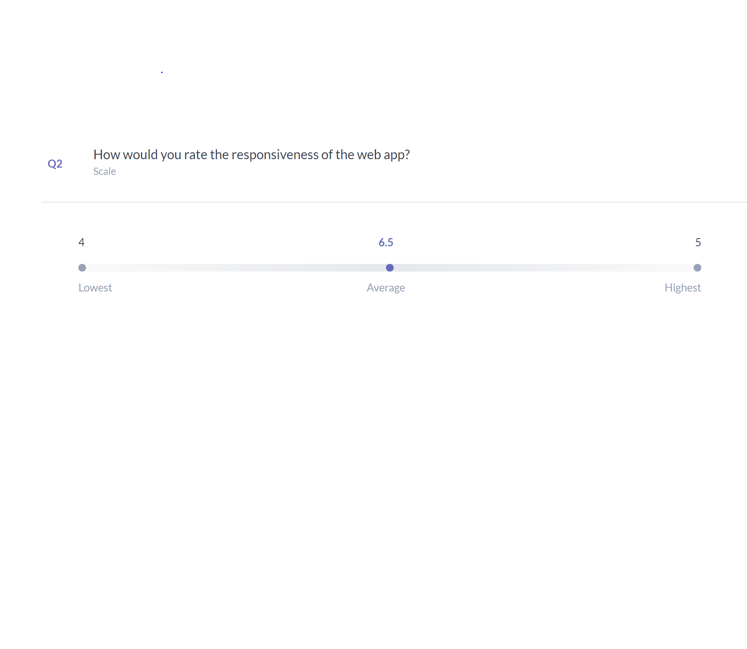

**Figure 5.10:** Question 2 Results

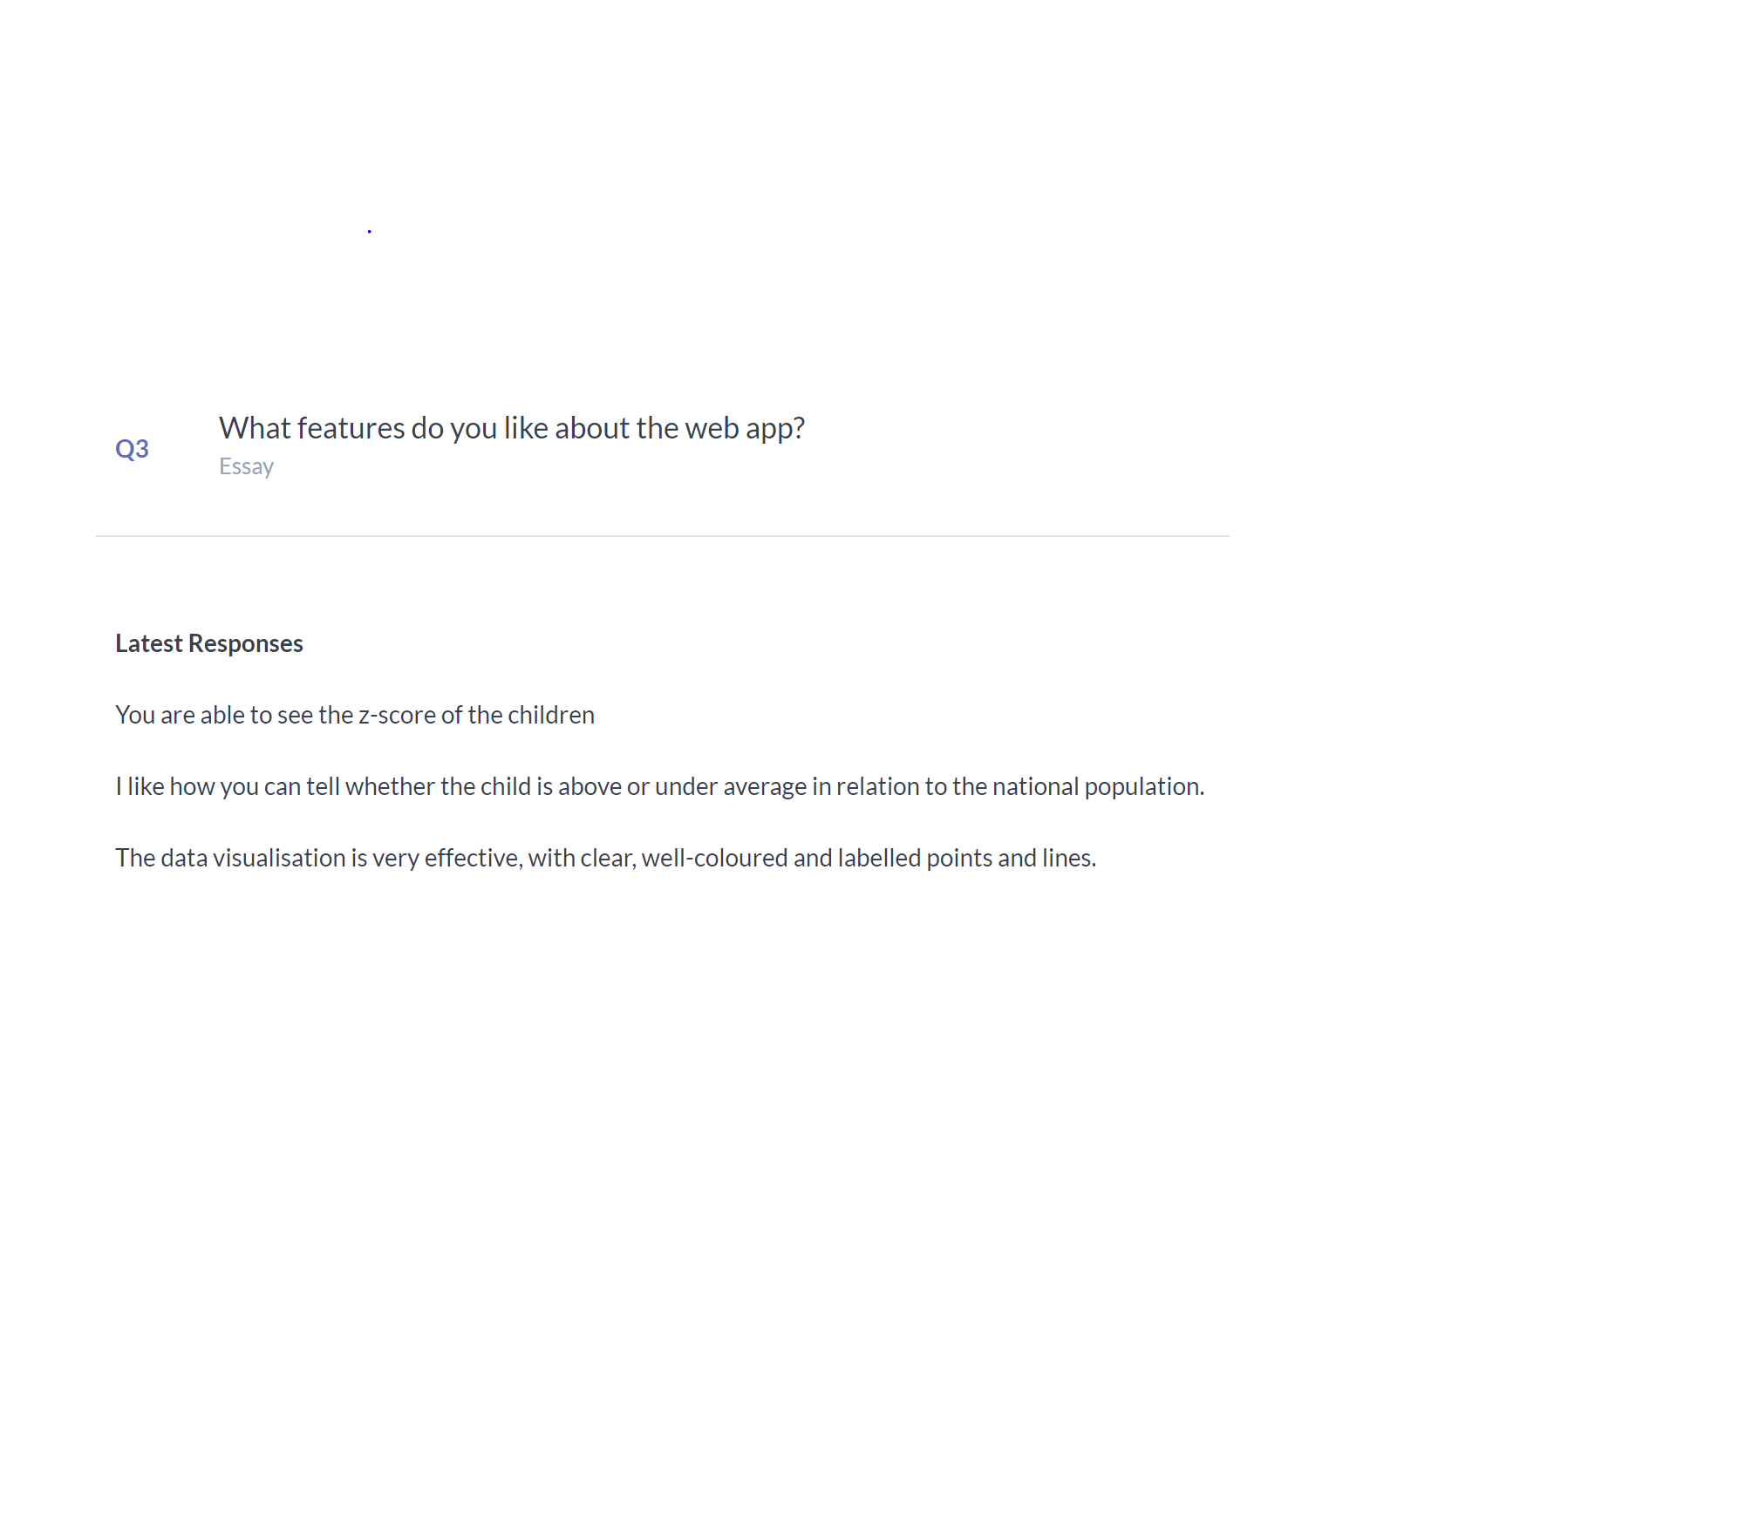

**Figure 5.11:** Question 3 Results

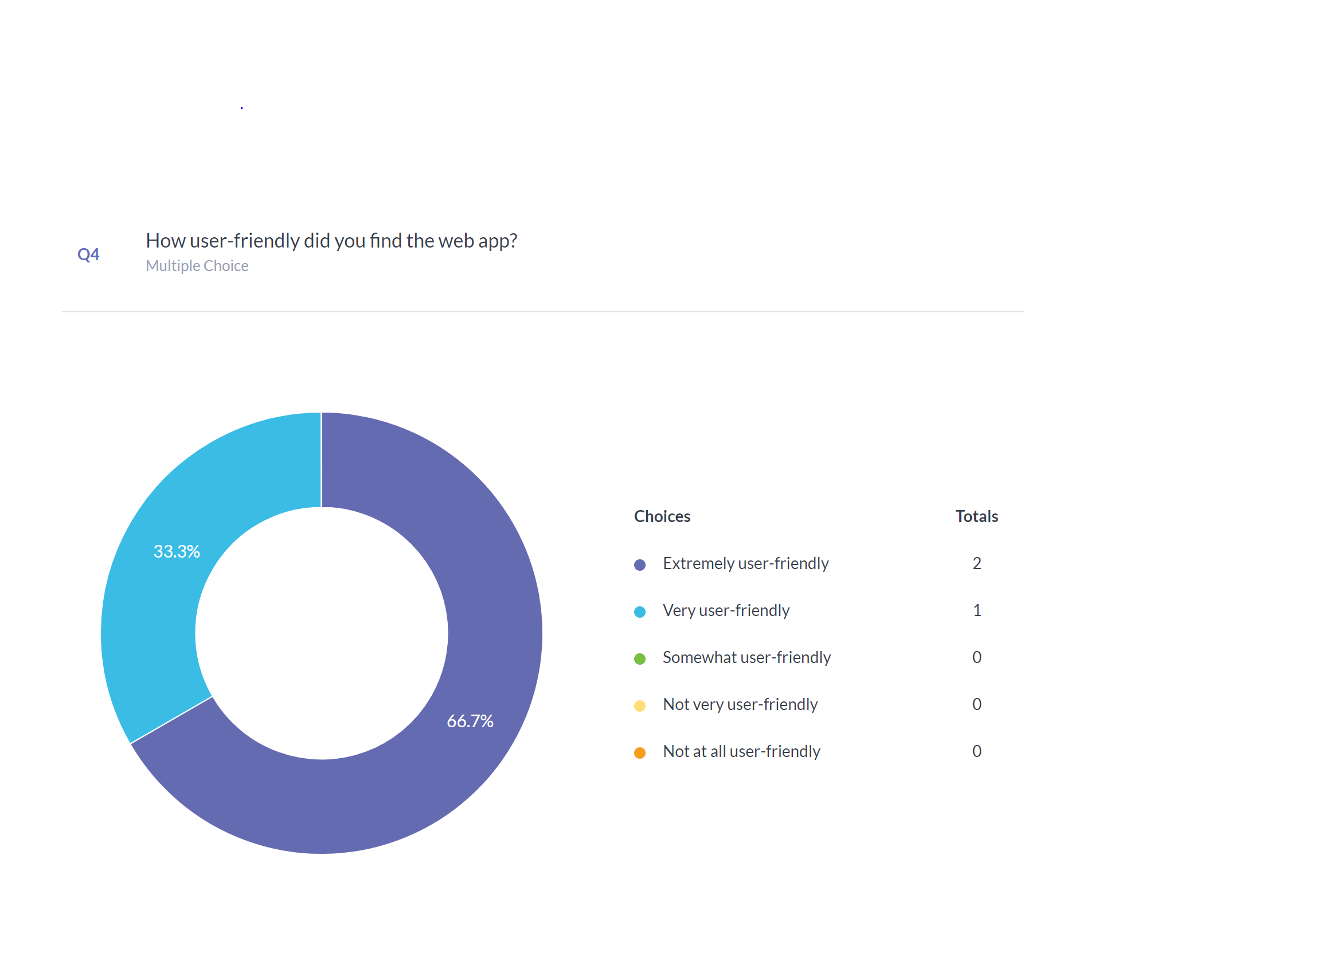

**Figure 5.12:** Question 4 Results

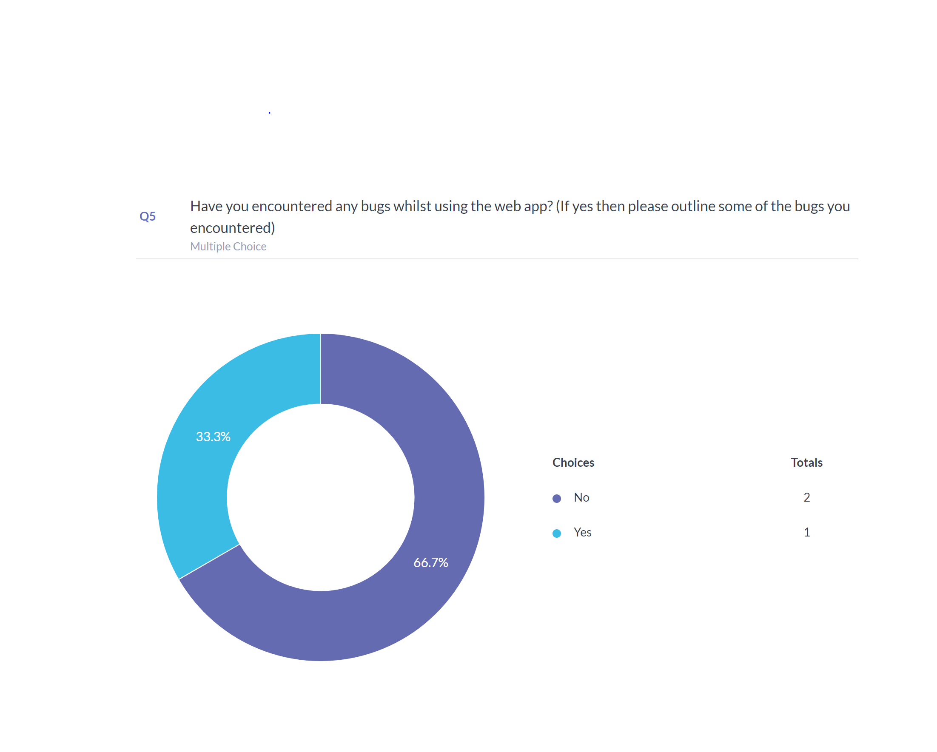

**Figure 5.13:** Question 5 Results

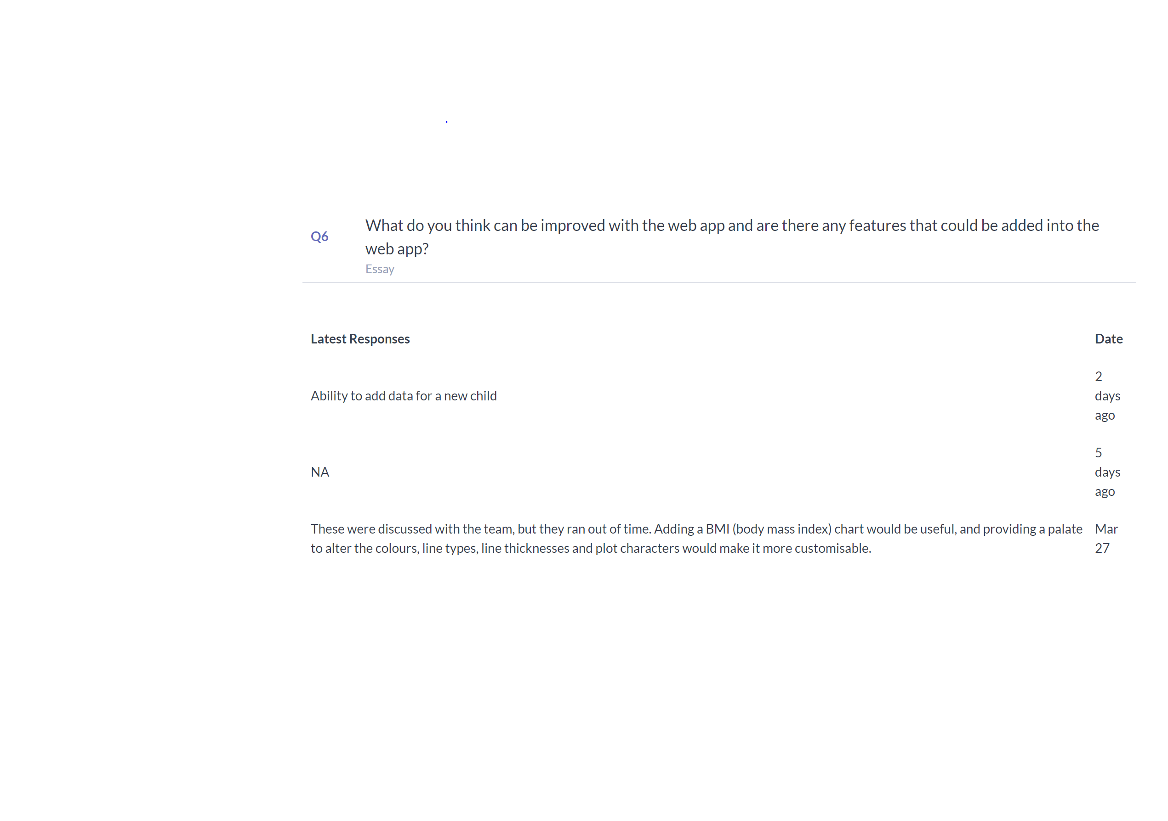

**Figure 5.14:**  Question 6 Results

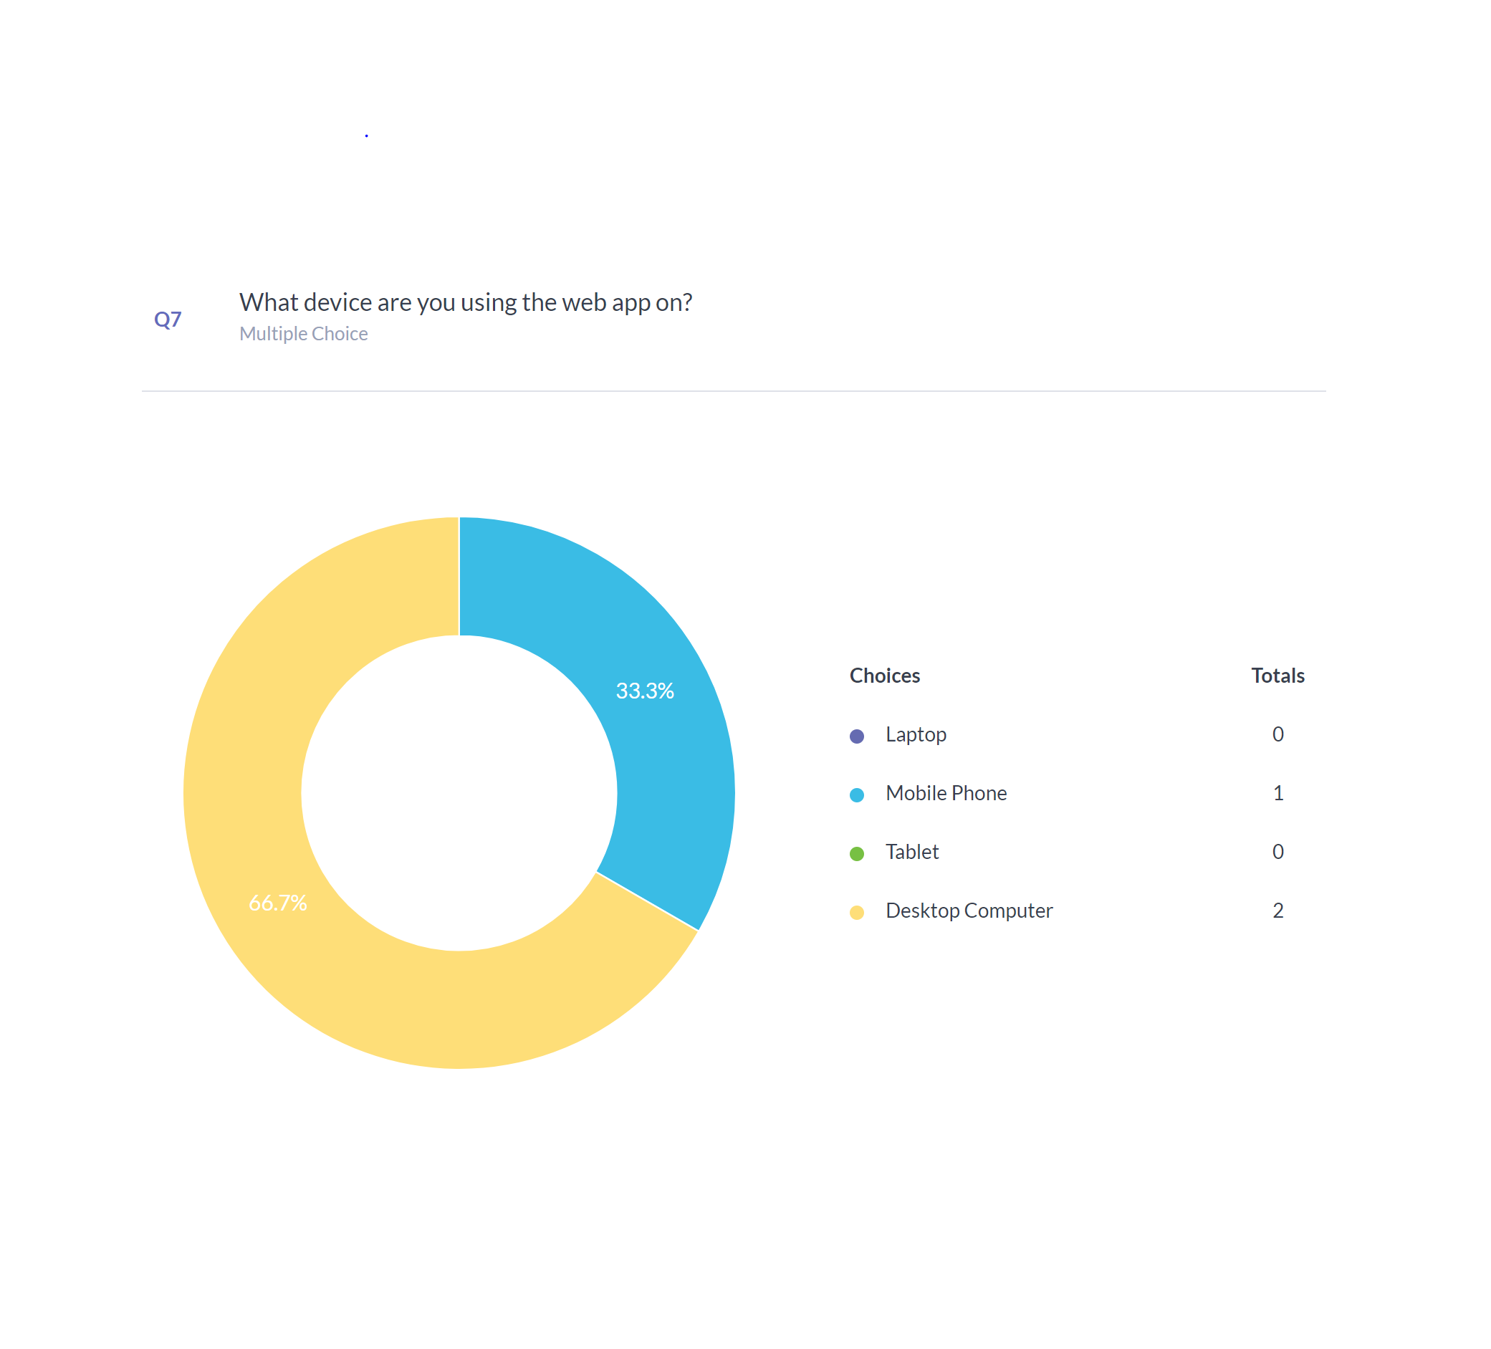

**Figure 5.15:** Question 7 Results

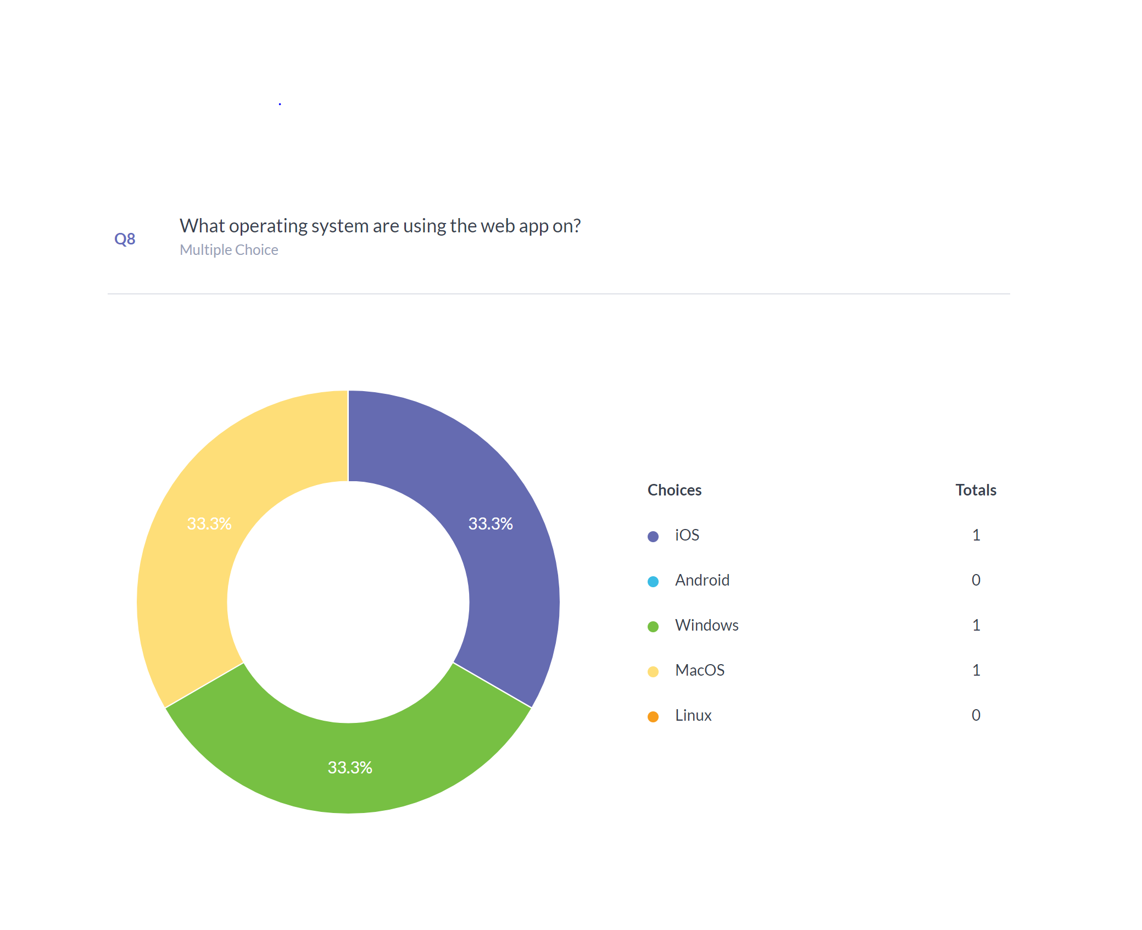

**Figure 5.16:**  Question 8 Results

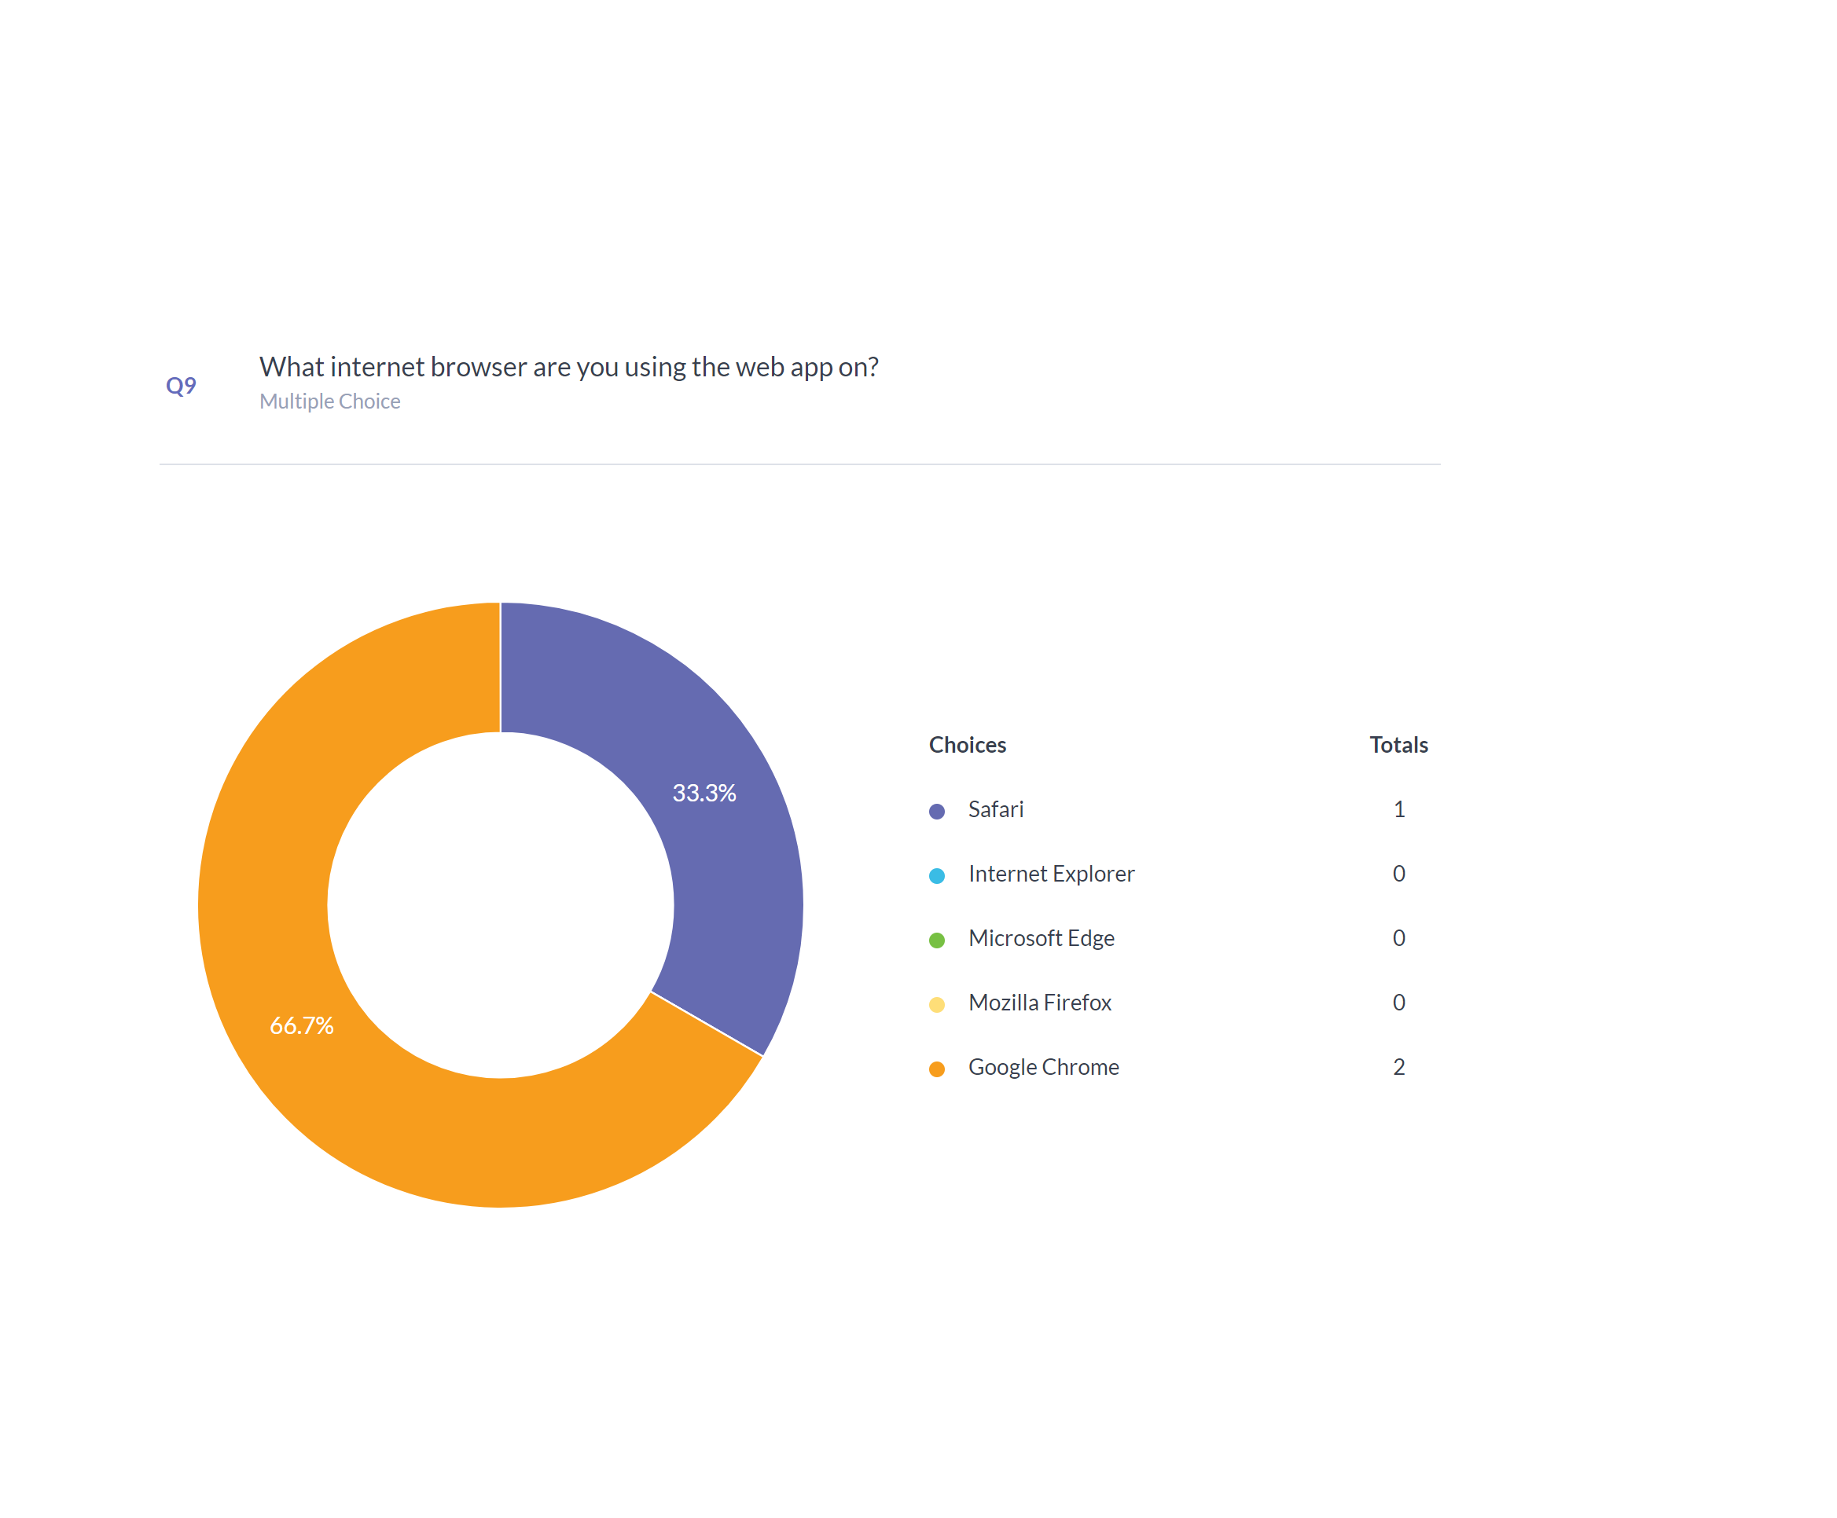

**Figure 5.17:** Question 9 Results



**Figure 5.18:** Question 10 Results

Overall, the survey gave positive feedback and only one bug was outlined (discussed in *6.1 Summary of Achievements*) as well as some improvements that could be made (discussed in *6.3 Future Work*).

# 6 Conclusion and future work

## 6.1 Summary of Achievements

**Achievement Table:**

|  |  |  |  |  |
| --- | --- | --- | --- | --- |
| ID | Requirements | Priority | State | Contributors |
| 1 | Plotting of serial measurements of an individual on a normal growth chart with centile detection | Must | **✓** | All |
| 2 | Plot height and weight growth charts | Must | **✓** | All |
| 3 | Have web app functionality | Must | **✓** | All |
| 4 | Use GOSH’s data to produce growth charts | Must | **✓** | All |
| 5 | Show some sort of growth trajectory using the data that is inputted | Should | **✓** | Rajan |
| 6 | Integrated with SMART on FHIR so it can be compatible with any health centre that uses SMART on FHIR for their data storage | Should | **X** | All |
| 7 | Have some functionality to output data to files or in a pdf format | Could | **X** | All |
| 8 | Have some functionality for data security | Could | **X** | All |
| 9 | Have some functionality for the application to run in a mobile browser | Could | **✓** | All |
| Key Functionalities (must have and should have) | | **83%** completed | | |
| Optional Functionalities (could have) | | **33%** completed | | |

**Contribution Table:**

|  |  |  |  |
| --- | --- | --- | --- |
| Work packages | Rajan | Saleh | Sander |
| Client liaison | 33% | 33% | 33% |
| Requirement analysis | 33% | 33% | 33% |
| Research | 20% | 40% | 40% |
| UI Design | 25% | 50% | 25% |
| Programming | 40% | 30% | 30% |
| Testing | 33% | 33% | 33% |
| Progress Report | 33% | 33% | 33% |
| Technical Report | 33% | 33% | 33% |
| Poster Design | 0% | 0% | 100% |
| Video Editing | 0% | 100% | 0% |
| Overall contribution | **40%** | **30%** | **30%** |
| Roles | **Report Editor, Programmer, Front End Developer** | **UI Designer, Researcher, Programmer** | **Report Editor, Programmer, Tester** |

**Bug Table:**

|  |  |  |
| --- | --- | --- |
| ID | Bug Description | Priority |
| 1 | Centile values in measurement graph were displaying incorrect values | High |
| 2 | The hover text for the centile values in the measurement graph display the centile value twice (from survey results) | Low |

Bug 1 has already been fixed. We encountered this bug during a meeting with our client and we saw that the z-score values were not matching up to the centile values. The bug was caused as the function that was creating the centile curves was creating a line of best fit and this was not what we wanted so we changed the source code and now the z-score values and the centile values match up.

## 6.2 Critical Evaluation of the project

**User Interface:**

From the survey results, testers believe that the website has a good user interface as it is easy to navigate through the website using the tabs and drop-down menus. The website will always have a title on each page of the website so the user knows what part of the website they are on. The visual aspects of the website make it easy for the user to understand what information is being displayed.

**Functionality:**

The website is easy to navigate through and is organised into tabs and nested tabs. From the survey results, the website is very user-friendly and so users find it easy to use the website and understand what the website does after telling them the background of the website.

**Compatibility:**

The website is compatible with any browser and on any platform, whether it is a laptop, desktop computer, mobile phone or a tablet. The users from the survey tested the website on different platforms and browsers and the website was compatible with those platforms.

**Maintainability:**

The website can be easily maintained. Currently, the website is being hosted on a shiny server, which has a numerous amount of feature and it is also very easy to update and expand the website. The source code just needs to be changed and added to and then the website can be redeployed on the shiny server.

**Project Management:**

The project was managed quite well. We had regular meetings with our client to discuss any issues and any details about the project as well as showing our client the progress of our website. The tasks for the project were split equally between the team to match our strengths in programming and designing. Also, the met up regularly once a week to discuss any problems we had and to discuss how to implement certain features into the website.

## 6.3 Future Work

The project could be extended in many different ways if there was more time to complete project. The website could display BMI centile values as well as weight and height. This would mean users would be able to see the BMI values of children and see how they compare with the centile values. Also, we could have implemented the SMART on FHIR data storage system so that the website would be able to handle the data of any health centre in the UK. Due to this feature not being implemented, the website uses sample data for the centile values as well as sample children data. Another feature that could be implemented is a customisation tool for the graphs so users can control certain aspects of the graph e.g. colour, layout etc.

# References

# Appendix

## **A** User Manual

The web application can be found at this URL: <https://ucl-cs-team14.shinyapps.io/GrowthCharts/>

## **B** Deployment Manual

After the client has the source code for the application, they can host it on whatever server they like. Currently, the web application is being hosted on a Shiny server on a basic subscription package. The client can upgrade the subscription package to have new features like authentication and adding authorised users.

## **C** Code Citation

|  |  |  |  |
| --- | --- | --- | --- |
| No. | Function Name | Code File Name | Source |
| 1 | z2cent | server.R | <https://github.com/statist7/sitar/blob/master/R/LMS2z.R> |